Chapter 10, Problem 57.

Using Fig. 10.100, design a problem to help other students better understand Thevenin and Norton equivalent circuits.

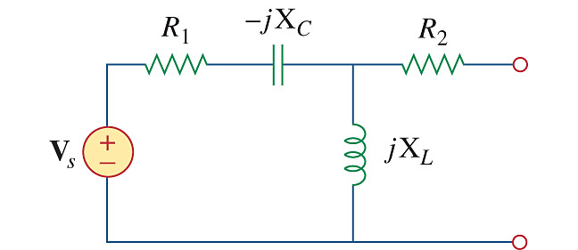

Figure 10.100
For Prob. 10.57.

